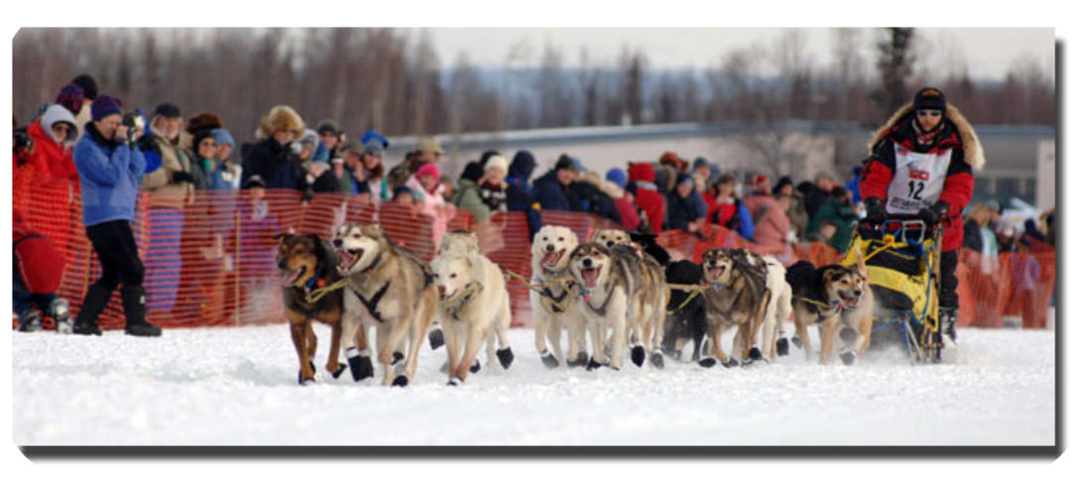
Iditarod Experiential Learning Program:
A revolution in academia

Are you leading your school into the next revolution in education? Do you want to be on the forefront of a new, exciting experience that enhances the way curriculum is presented to students? The Iditarod Experiential Learning Program is helping schools to:
- Cut costs
- Improve student performance
- Increase school attendance
- Provide real-life experiences
- Assist teachers with workload
- Improve effective teaching strategies.

Imagine your students experiencing the snowy mountains and icy glaciers of the Alaskan terrain without leaving the classroom. With the Iditarod Experiential Learning Program (IELP), your students can experience the true beauty and adventure of Alaska while tapping the benefits of an adventurous learning experience. But what is the Iditarod and the Iditarod Experiential Learning Program, and how can it help you achieve these goals?

A Teacher’s Thoughts on the IELP
“The race, the mushers, and the dogs catch the students’ interest and provide real-life examples of the skills the students need to master. Students use the information to make connections to what they are learning and to their own lives, finding similarities and differences in their lives and their surroundings.”

Martha Dobson, 2011 Teacher on the Trail, Charlotte, NC



What is the Iditarod?
The Iditarod is a sled dog race with a history. The race is run each year to commemorate a myriad of feats that were, and still are, overcome with the help of sled dogs. In the undeveloped Alaskan wilderness, humans relied on sled dogs to send and receive mail, deliver supplies, and travel. And that’s just the race, but what about the IELP?

Teachers Choose IELP Because it Works
- The standards aligned curriculum is created by teachers, for teachers.

- Teachers and students become invested in the work and the results.

- Students make personal and emotional connections to the themes and enjoy the reality-based topics.

- IELP is place- and project-based, so the content is applicable in all subject areas and geographical regions.

- The program promotes communication and problem-solving skills by incorporating new technology.
- 
- (Source: http://iditarodblogs.com/teachers/mission-statement-and-goals/)

What is the Iditarod Experiential Learning Program (IELP)?
The Iditarod Experiential Learning Program is unlike any other. It’s experiential learning from thousands of miles away! The IELP uses the excitement of students, mushers, dogs, volunteers, and everyone who participates as teaching tools.
The IELP can relate to any subject at any grade level. The regions in Alaska used for the Iditarod trail can be incorporated into history and geography courses. A teacher can have their students “race” with the mushers, each choosing one to represent, and then track their progress using math to figure out the speed and times of the mushers. With the Iditarod Insider, a class can even take virtual field trips, which not only save time and money but help educators offer students greater opportunities. Here is what Jeannie Oakes at Education Week has to say about IELP application:

One of the best features about this program is that it can work in any region. Classrooms in regions without snow can even have “sled dog” teams with wheels in place of skis. Temperature differences make excellent springboards for discussion in science courses. Many teachers already believe they can teach any subject with the Iditarod Experiential Learning Program.

Lesson plans or ‘proven models’ from another school or district might inform a program’s starting point, but soon will develop in unexpected ways as the school mediates its local circumstances.

Benefits of the Iditarod Experiential Learning Program
Being an educator is perhaps one of the most stressful yet important careers one can undertake. The developers and community of the IELP understand this. We offer this program to provide educators with:
- Financial Benefits
- Benefits for Teachers
- Effective and Relevant Education Tips.

Financial Benefits
As we all know, the current downturn in the economy is affecting every area in society, including education. With educators like you facing enormous budget cuts, layoffs, and the challenge of providing students with a competitive education, fiscal responsibility influences every decision.

Financial Benefits (continued)
But the IELP is a low-cost program and most of the resources are even free. Cost-effective subscriptions to Iditarod Insider give access to special features (such as GPS Tracker, Videos, Newsletters, and more) that allow educators to get the most out of the Iditarod Experiential Learning Program. Using the IELP, schools spend less money while helping educators teach in new and creative ways. Though finances are important, the main purpose of education remains to ensure that students are provided with the necessary skills to succeed, and with the help of the IELP, educators across the United States and around the globe are making tnhis vision a reality.


The IELP is Used All Over the United States and Around the Globe!
For two years a teacher in Maine has used the IELP, and she is using it again this year with her students in grades 3-5. She finds that the IELP is useful for her students’ skills in reading, writing, math, and relating them to real life situations.
Source:
(http://idtiarodblogs.com/teachers/2011/02/14/a-teacher-in-maine-shares-goals-for-idtiarodprojects/)
A school in Ohio has four fourth grade classes using the IELP to create a cross-curricular unit that includes activities in math, social studies, language arts, and technology. The students choose mushers, chart their progress, write letters to the mushers, and complete reports and personal narratives for class projects.
Source:
(http://iditarodblogs.com/teachers/2010/03/19/iditarod-in-the-50-states/)
A school in Japan is currently using the program to build students’ English through science and social studies projects. The school has already used the IELP for four years and is continuing to expand its use.
Source:
(http://idtiadblogs.com/teachers/2011/12/13/idit-in-japan)

Benefits for Teachers
Whether teaching a class of 30+ children or spending their own money on school supplies, teachers are the backbone of the education system. Daily, teachers are subjected to physical and emotional stress that can wear down their ability to teach effectively. The IELP helps to relieve some of this stress by:
- Offering pre-planned lessons (all of which meet, or can be adjusted to meet, individual state standards)
- Providing a community and forum for discussing new ideas with other teachers around the globe.

- Inventing new ways for implementing experiential learning

Decreasing teacher stress can result in a better overall classroom experience for the students.
Effective and Relevant Education
But exactly how does the Iditarod Experiential Learning Program increase the efficiency of education? The IELP is not a set of courses alone, but a conduit through which the required subjects are taught and educational standards met.

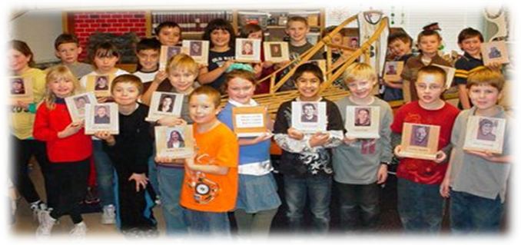

Effective and Relevant Education
The Iditarod Insider supplies teachers with additional data and content which can help teachers implement the IELP in accordance with district, state, and nationwide standards. Where the Iditarod Experiential Learning Program has been used, teachers have seen a rise in test scores, improved self-discipline among students, and better overall performance of students involved in the program. The IELP also connects students to a larger community, where they can relate their learning to real world situations. All of this allows the IELP to provide educational opportunities that otherwise might not be possible such as:
- Using the GPS Tracker (included in the Iditarod Insider Package), Skype, and other computer programs and technologies
- Turning students from passive to active learners
- Developing teamwork and collaborative skills with classmates and even with the racers in the Iditarod
- Increasing student interest in school
- Offering different experiences at each grade level.

“I have been teaching the Iditarod-themed Lesson Plans for years to students of all abilities and grade levels, 3rd – 6th grade. All kids get it! They love learning through exploration and hands-on, internet research. Get them out of the textbooks and into the real world, in an uncharted area, with the excitement of a race, and HOLD ON! The kids will drive the lessons and the teacher becomes the facilitator. It's learning at its best.”

Bonnie Edwards, M.Ed
Roland Park School of Choice K-8, Tampa, Florida

No other educational program offers an experience like the IELP! There is nothing to lose by trying the Iditarod Experiential Learning Program, but much to gain for a child's education.

What now?
To lead your school into the next success, act now and return an email for additional information or visit us at www.iditarod.com and click the tab For Teachers.

Sincerely,
Diane Johnson
Dianne Johnson, Director of the
Iditarod Experiential Learning Program

P.S. The race begins on the first Saturday every March. Your students are waiting at the starting line. Where are you?

