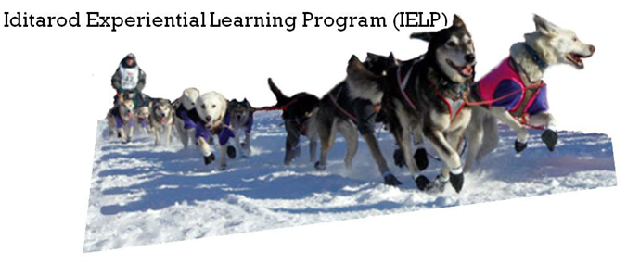

What would you do to save money while improving your school’s performance? Would you trek hundreds of miles over jagged mountain ranges and frozen rivers, through dense forests and desolate tundra, across miles of windswept coast, while being pulled on a sled by a dozen dogs? Don’t worry, you don’t have to. The Iditarod Education Department has created a tool that gives you the benefits of adventure while helping you manage costs and enhance performance right in your own school.

What is the Iditarod?

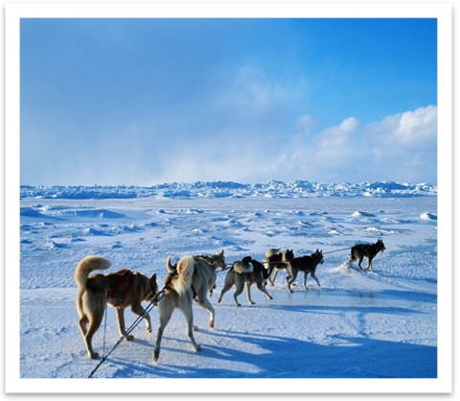
The Iditarod has been called the “Last Great Race on Earth” for a good reason. It is a sled dog race that starts in Anchorage, Alaska and ends over 1,000 miles away in Nome. The landscape is treacherous, and the weather is unforgiving.

This race serves to memorialize all the things sled dogs have done in history and for the people of Alaska, but part of the trail raced today is the historical trail mushers used to bring life-saving medicine to Nome during an epidemic of diphtheria in 1925.

Now, mushers enter the race from all walks of life to honor this lifestyle: fishermen, lawyers, doctors, miners, artists, natives – Canadians, Americans, Swiss, French and others – each go the distance with their own story and reasons.

What is the Iditarod Experiential Learning Program (IELP)?

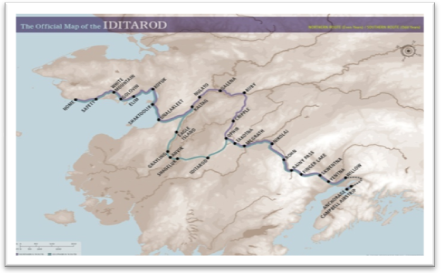
The Iditarod Experiential Learning Program is a year-round tool with lesson connections for all curricula that help inspire necessary life skills to benefit students. The program uses Iditarod-themed lesson plans along with experiential learning techniques to teach students standard curricula. Anyone can follow the race at the Iditarod website, at no cost to them, where they can read the discussion forums and have access to educators’ lessons plans; however, when you join the program as an Iditarod Insider, you will receive exclusive access to valuable tools to help enhance the learning experience. The Iditarod Insider for Teachers is a subscription that provides exclusive interviews, special interest stories, action videos, interactive maps, GPS trackers, and other fun tools to incorporate into traditional classroom instruction. You also have access to daily video segments of the actual race that will be uploaded to the website so you don’t have to miss a minute of Iditarod coverage!

Depending on which one you choose, the following are some important tools provided by each subscription:

- Insider GPS Tracker lets you follow the entire trail, 24 hours a day, until the very last team reaches Nome. You'll know how fast teams are traveling, the distance between teams and the current temperatures at each checkpoint along the way.

- Iditarod Insider Video on Demand streams hundreds of video segments online over the course of the Iditarod, from behind-the-scenes interviews through to the thrilling Live Finish in Nome. With Insider Video on Demand, you won’t miss a minute of the action before or after the race! In fact, you can replay the entire adventure, anywhere, any time of the year.

- Ultimate Insider GPS Tracker combines the benefits of both the Insider GPS Tracker and Iditarod Insider Video on Demand to keep your students updated on everything Iditarod.

What are the benefits?

The IELP is an affordable solution to many of the problems schools are facing today. It can help your school to:

- Spend less money more efficiently
- Enhance student learning
- Improve school performance
- Relieve educator stress and burden.

Spend Less Money More Efficiently

In a time of budget cuts and layoffs, educators are looking for creative and innovative ways to teach their students at a lower cost. The IELP is free supplemental tool that helps teachers cover many classroom subjects at any level, so administrators and teachers can meet state standards despite the constraints of a shrinking budget. Along with meeting your state’s standards, IELP also helps reduce out-of-pocket costs for teachers. The tried-and-true educational materials you need are freely accessible online, which saves time and money for both teachers and schools. With the cost-effectiveness of free teacher-prepared lesson plans, you can’t afford to miss out.

Reading and language arts teacher, Bonnie Edwards, from Tampa, Florida writes:

“I have been teaching the Iditarod-themed Lesson Plans for years to students of all abilities and grade levels, 3rd – 6th grade. All kids get it! They love learning through exploration, hands on, internet research. Get them out of the textbooks and into the real world, in an uncharted area, with the excitement of a race, and HOLD ON! The kids will drive the lessons and the teacher becomes the facilitator. It's learning at its best.”

Enhance Student Learning

Thousands of principals and teachers have already unlocked the potential of the Iditarod Experiential Learning Program in the classroom. The Iditarod-themed lesson plans are very effective because students get excited about the novelty, adventure, and high stakes competition that the race presents.

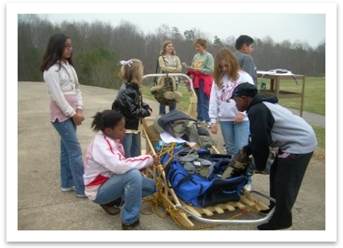
With the GPS tracking included in an Iditarod Insider subscription, students can learn math by calculating the fastest average speeds, the estimated arrival time for each musher, the probability of each musher finishing, and more. Students can study the biology of the dogs and the physical stress that mushers endure while on the trail. To enhance their language skills, students can also write creative stories about being on the trail from the dog or musher’s perspective or use Iditarod concepts to learn new vocabulary. There are so many educational opportunities provided by the Iditarod race and the Iditarod Education Department; students can spend years learning through the program without ever losing interest.

The IELP offers experiential learning techniques to keep students interested in the subject they are studying and helps them retain information. Stimulating the interest of students with nontraditional approaches to coursework inspires them to participate in class discussions and lessons. By becoming involved in the race and seeing real-world applications of the subjects and skills they learn in class, students are more likely to do well on tests and homework, since they are mentally and physically engaged in the work.

The benefits of the IELP aren’t restricted to any particular group; students in private or public school, Special Education, and ESL programs can all learn through the race. A subscriber of the Iditarod Insider, IditarodFanInSC, uses the Iditarod trail map with tactile markings and cities written in Braille to teach blind and visually-impaired children. Students can even learn during extracurricular events such as after school programs and summer camps.

Improve School Performance

The IELP has a solid reputation for improving learning in many schools around the globe. Experiential learning techniques help schools to:

- Allow teachers to become more efficient
- Keep students coming to class
- Increase student performance
Joy Davis, a high school teacher from Indiana writes:
“Teachers internationally use this topic for their curriculum enrichment. We all teach to our state standards by using the race and the people as the medium.”

- Decrease drop-out rates

- Improve students’ self-discipline.

These improvements help create healthier learning environments that are advantageous to all students. They also give students the essential building blocks of 21st century skills in technology and teamwork to become successful in their life endeavors.

Because the amount of funding schools receive is based on how well students score on standardized tests, the greatest advantage to using IELP is heightened academic performance. The program has been proven to meet state standards around the country. One of the highest priorities when providing a program to a school is to supplement existing teaching methods. This ensures that all areas in the curricula are fully covered and understood by the students, so they can perform to the best of their abilities.

Relieve Educator Stress and Burden

Administrators and teachers are under immense pressure to meet state standards while working under drastically reduced budgets. Some of this pressure can be relieved with the pre-made lesson plans and activities that the Iditarod Education Department provides. Teachers can incorporate the Iditarod theme into lessons that are already part of the curriculum.

How much can I save with an Iditarod Insider Plan?

Thousands of teachers and principals have already saved with a subscription to the Iditarod Insider! You choose the plan; you choose what you want. A subscription allows you exclusive access to tools such as interactive maps, media, and PowerPoint presentations that are not accessible on the website.

The prices for each package are listed below:

Iditarod Insider Package Prices

Iditarod Insider Plan | Classroom Cost | School Cost
Insider GPS Tracker | $39.95 | $99.95
Insider Video on Demand | $39.95 | $99.95
Ultimate Insider | $67.95 | $169.95

With our unique plans, you only pay for what you need. So, if you feel that your class benefits from the Iditarod Insider, you can upgrade to a school-wide package to further reduce the cost per student at your school!

How do I sign up?

To sign up, go to the Iditarod Insider website at iditarod.insider.com and click on “Become an Insider.” Choose the classroom or school wide subscription that meets your needs. Fill out the necessary information to start your subscription today! The Iditarod race begins the first Saturday of every March, and if you register now, your students can get immediate access to the race and all the Iditarod Insider has to offer!

So get in the race and become an inspiration to your students, to your school, and to others around the globe!

Thanks for your consideration,

Diane Johnson
The Iditarod Education Department

