Iditarod in the Classroom by Martha Dobson
Teaching your state’s education standards is an expectation across the United States’ school systems. Teachers are provided textbooks and workbooks, but we’re always on the lookout for the “something more”, something that will capture students’ interest and give them another tool to learn and practice the standards’ skills. The Iditarod Trail Sled Dog Race™ is such a tool.

In my classroom, nothing sparks students’ interest like the Iditarod does. At first, students are hooked by the dogs and the differentness of the event and the place, Alaska. I use this hook to draw them deeper into the race and the state, teaching the North Carolina Standard Course of Study (NCSCOS) and following my school system’s yearly pacing guide for English/language arts. The race is a perfect fit for studying author’s purpose, nonfiction, and informational selections in language arts. I know they are interested and engaged because I hear comments such as “This is cool!”, “Is it cold?” , “Look at that dog!”, and “It must be hard to run the race.” A survey of 93 current and former students indicates interest levels of 70% to 84% in activities using the Iditarod. (Dobson, 2010).
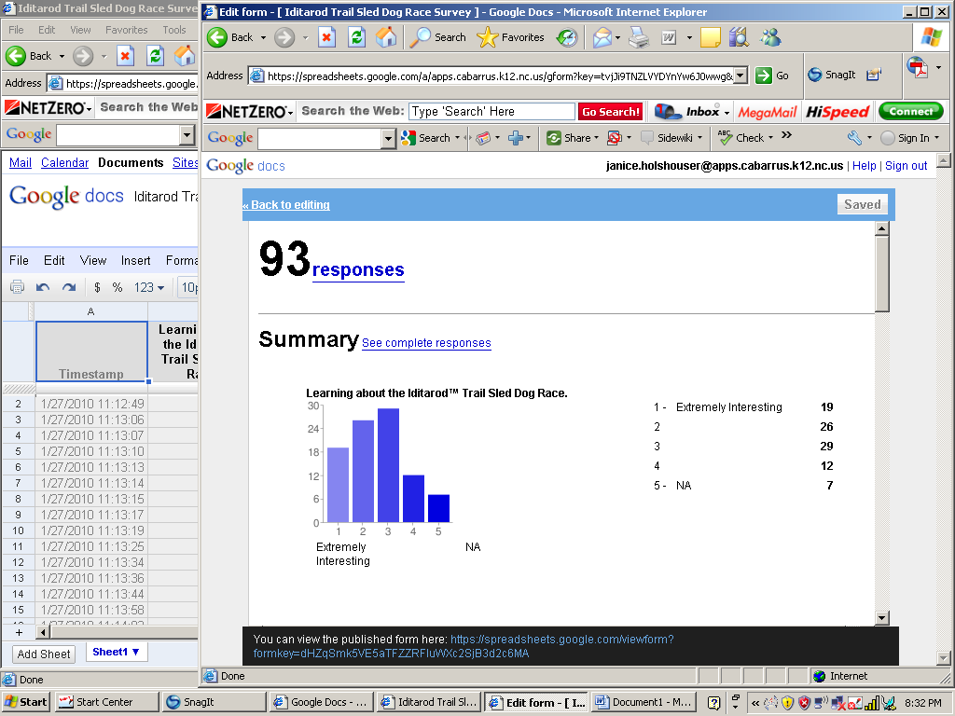
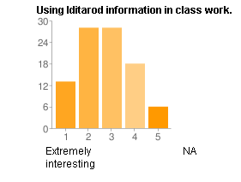
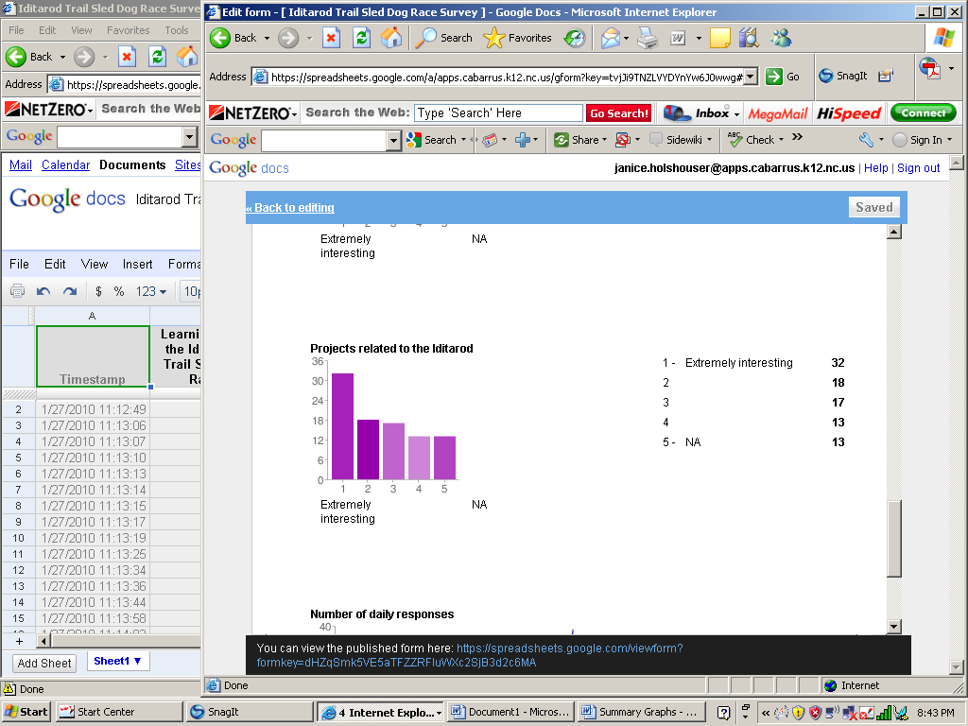

Madeline Hunter’s book, Mastery Learning, addresses increasing students’ motivation by making learning vivid, and one way to do that is “by stressing the novel aspect or differentness of the material itself.” “Almost everything we teach can be related to the student’s own life, thereby making that content more interesting.”(Hunter, 1982). Interested and engaged learners learn and practice the skills taught.

I have connected state standards in and out of my classroom subject with ease while engaging students. The Iditarod’s information lends itself to science (genetics, weather), technology (research and word processing skills), math (word problems with actual race statistics and situations, graphing), language arts (create brochures, MLA format, read and analyze nonfiction/informational articles, analyze figurative language), art (collages, design race bibs, Christmas decorations), and social studies (create quilt squares based on the five themes of geography). These activities actively engage students, a critical tenet stated by the National Middle School Association’s position paper, This We Believe-Keys to Educating Young Adolescents. “Successful middle grades schools are characterized by the active engagement of students and teachers.” (NMSA, 2010).

In middle school, teachers work to move students from the concrete levels of thinking to the higher order thinking skills of applying, analyzing, evaluating, and creating. (revised Bloom’s Taxonomy). This is necessary for students to succeed in applying skills taught to their work on standardized testing and in real life. The Iditarod, a real event with real life challenges that are metaphors for the students’ own challenges, provides another tool to practice these higher order skills. Students in past classes created advertisements to persuade others to buy an inflatable doghouse, analyzed a comparison and contrast article between their hometown and McGrath, Alaska, and read race updates and accurately transferred data to charts to update mushers’race progress. In fact, I use a released Iditarod test selection and questions created for a standardized end of the year test as a practice item for students. (What’s a Musher?, 2008). Standardized testing recognizes it as an appropriate topic for students!

Middle school is also a time for teachers to teach and students to learn how the education standards and skills relate to their future lives outside the classroom. Again, the Iditarod is a tool by which this is achieved. Everyone has something in school that challenges them, something that they will have to use in real life. Math may be their school challenge, but figuring the amount of tip for a meal or the amount of discount on a sale item are real life skills. Reading and writing may be another student’s challenge, but it’s necessary to accurately complete job applications and carry out job responsibilities. The race models how people handle challenges and overcome them. Students can relate the race challenge to their own lives. My students learn that it’s important to finish, not finish first, just like the Red Lantern winner of the Iditarod, the last finisher. For example, they know that achieving their point goal in the Reading Counts program is important to improve their reading and their skills in working towards a goal. Being the first person to reach their point goal is not the most important goal. Perseverance is a trait that stands every person in good stead in the classroom and in life; the race is a phenomenal example of that trait.

A teacher with firsthand knowledge and experience of the Iditarod and Alaska brings expertise with credence to the classroom. Reading about the race is one thing; having observed it, heard it, or been part of it gives teachers additional credentials to use it successfully in the classroom. The teacher’s personal experiences add depth to the students’ experience in the classroom. Attend one of the two Educators’ Conferences each year to experience the race and learn how to connect it to the standards taught.

Iditarod Interest Survey, Martha Dobson. (2010). Martha.dobson@cabarrus.k12.nc.us.

Hunter, M. (1982). Mastery Teaching. El Segundo, CA: TIP Publications.

National Middle School Association (NMSA). (2010). This We Believe-Keys to Educating Young Adolescents. Columbus, OH: Author.

Anderson, L.W., & Krathwohl (Eds.). (2001). A Taxonomy for Learning, Teaching, and Assessing: A Revision of Bloom's Taxonomy of Educational Objectives. New York: Longman.

“What’s a Musher?” North Carolina Public Schools. (April 2008). 23 January 2010. http://www.ncpublicschools.org/docs/accountability/testing/eog/reading/20080421g5set3.pdf

